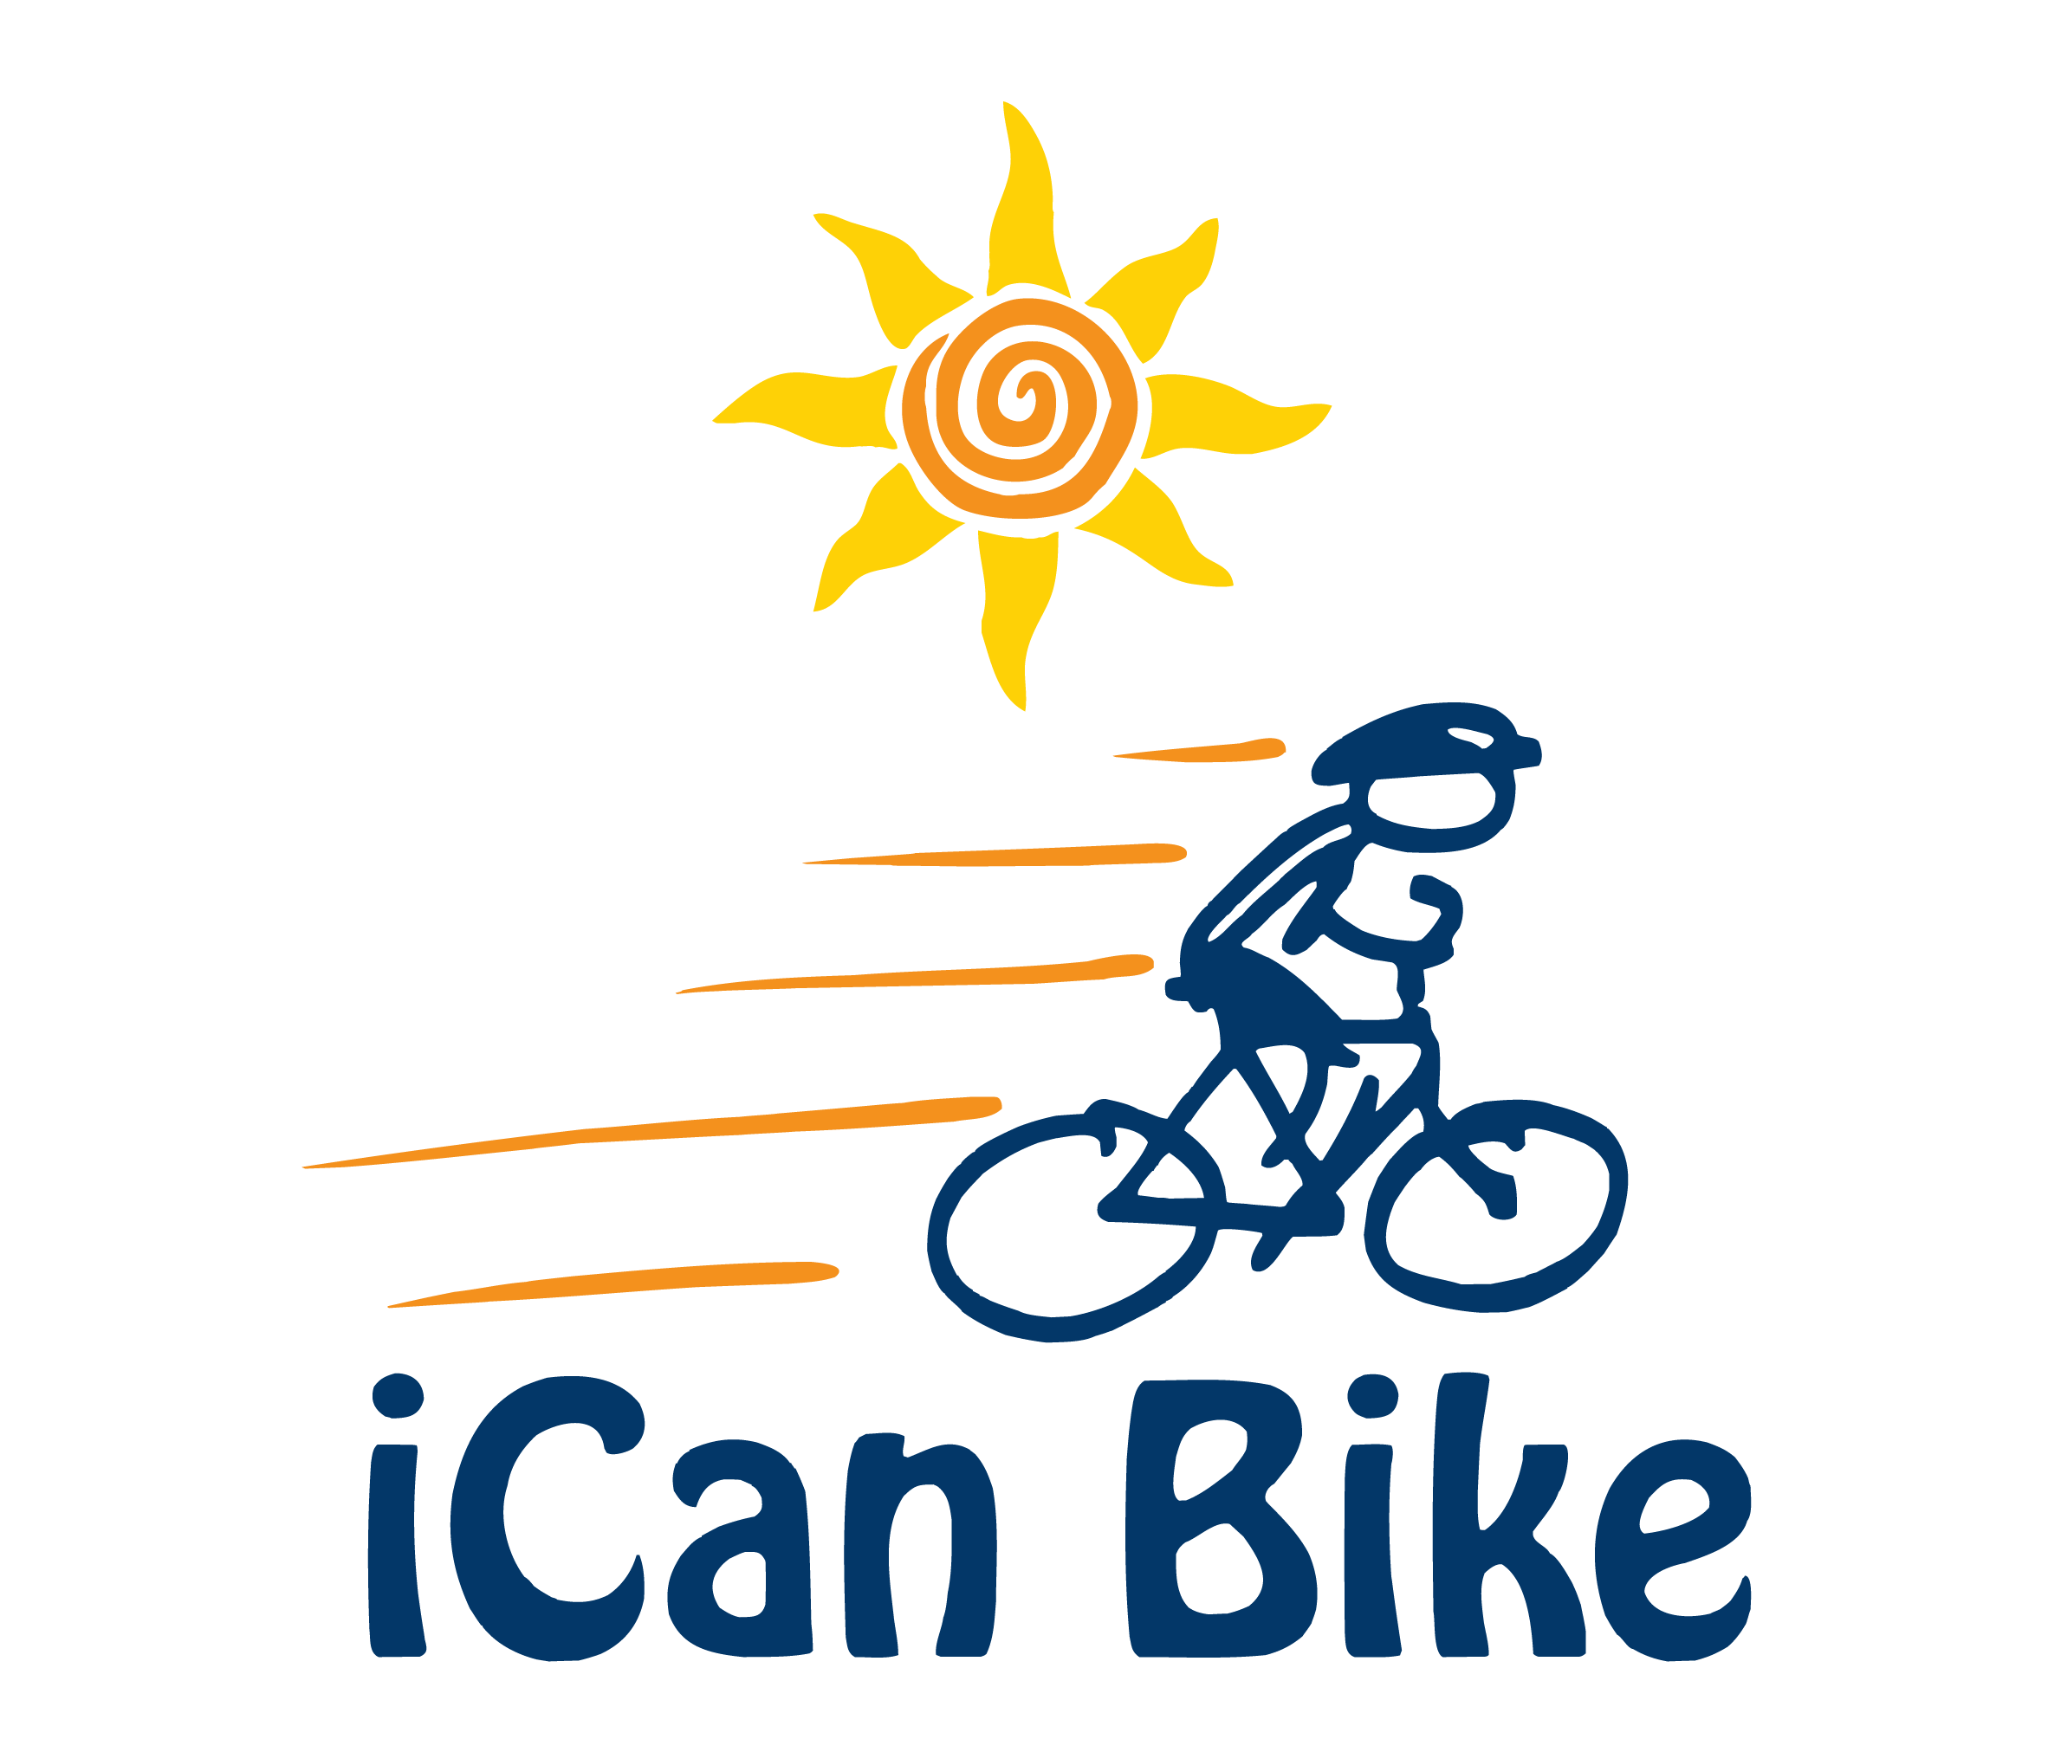

Volunteer Registration Form
Island Health, July 10-14, 2023 at Panorama Rec Center

We are pleased to offer this bike program to people with disabilities and look forward to having you play an important part in helping our special riders learn to ride a two-wheel bicycle independently

***NO PRIOR EXPERIENCE WORKING WITH PEOPLE WITH DISABILITIES IS NECESSARY***

AGE REQUIREMENT: Volunteers must be at least 15 years old

Volunteer Information:

Name:
Age:
T-Shirt Size:
E-Mail:
Cell Phone:
Home Street Address:
Home Address City, State, Zip:
Emergency Contact Name:
Emergency Contact Phone:

Comments:

Will you need documentation of service hours?
If yes, please provide documentation to Host on final day of volunteering
⎕Yes ⎕No

Volunteer Orientation:

Please plan to attend our 45-minute orientation on Sunday July 9th at 7pm. Location is Panorama Rec Center; 1885 Forest Park Drive, North Saanich. During this orientation, you will learn about how the iCan Bike program operates, what to expect each day in your role as a volunteer spotter and you will receive training tips on spotting your assigned rider. There will also be an opportunity to ask questions and meet other volunteers in your session.

NOTE: Please plan to arrive each day of camp 20 minutes prior to your session start time for a daily strategy/briefing session.

Volunteer Role:

Spotter: Walk/jog/run alongside a rider as they are learning to ride a bike during a 75-minute session (with short breaks) for 5 days Monday through Friday. You will provide encouragement and physical support, as needed.

Please place an “X” in the box below indicating your highest level of fitness:

I can jog at a vigorous pace for one hour with short breaks

I can jog at a moderate pace for one hour with short breaks

I can jog at a moderate pace for 30 minutes with short breaks and walk fast the remaining 30 minutes with short breaks

I can walk fast for one hour with short breaks

I can walk fast for 30 minutes with short breaks and walk the remaining 30 minutes at a moderate pace with short breaks

I can walk at a moderate pace for one hour with short breaks

I cannot walk steadily for one hour with short breaks

Comments (e.g. physical limitations, prior experience with children with disabilities, etc.):

Session(s) Volunteering For:

NOTE: Volunteer spotters will walk/jog approximately 3 miles during each 75-minute session so please keep this in mind if considering volunteering for multiple sessions. Unless you are very athletic, you may want to consider not volunteering for more than two (2) sessions per day.

We encourage volunteers to commit to attending all 5 days of camp for the session(s) selected. Riders bond with their assigned volunteer(s) and rely on the same person to be there to support them each day of camp. We do understand this is not always a possibility and will welcome volunteers any days they can attend.

Please place an “X” in the box(es) indicating the 75-minute session(s) for which you would like to volunteer (you will work with a different rider for each session you choose):

Session #1: 8:30 am – 9:45 am
Session #2: 10:05 am – 11:20 am
Session #3: 11:40 am – 12:55 pm
Session #4: 2:00 pm – 3:15 pm
Session #5: 3:35 pm – 4:50 pm
I would be interested in helping to spot a rider, still needing support, after the iCan Bike camp has ended.
I’m available to help unpack/move the bike equipment an hour prior to the start of the Sunday Orientation.
I’m available to help pack-up/move the bike equipment after the last session of the last day of camp.
Comments (e.g. day you cannot attend or will be arriving late):

Submission Instructions:

Please e-mail this completed Volunteer Registration Form, including below Liability release to volunteerhere@islandhealth.ca

Volunteer Acknowledgment & Liability Release
(Mandatory for Participation)

Volunteer Name: ________________________________________
Volunteer’s Parent Name (if Volunteer is under 18 years old): __________________________

The undersigned hereby agrees to the following:

1. Assumption of Risk:

I,________________________, am the above Volunteer (if at least 18 years old) or indicated Volunteer’s parent or legal guardian (if Volunteer is under 18 years old) and, for myself or on behalf of said Volunteer, have fully read the accompanying iCan Bike Volunteer Registration Form and the related materials made available to me describing the iCan Bike program (“Camp”), and I am aware of, understand, and assume the unavoidable risks of the inherently dangerous activity of spotting someone engaged in bicycling, which involves movement and physical exertion that could result in, but not be limited to, severe bodily injury or death.

2. Release of Liability:

In consideration of iCan Shine, Inc. (“iCan Shine”), its affiliates Island Health and Panorama Rec Center/Capital Region District allowing the above named Volunteer’s participation in the Camp, I, for myself and on behalf of said Volunteer, our heirs, administrators, personal representatives or assigns, hereby agree to release, indemnify, hold harmless and discharge iCan Shine, its owners, agents, employees, officers, executives, directors, representatives, affiliates, assigns, Rainbow Trainers, Inc., Island Health, Panorama Rec Center, Capital Region District and their agents, employees, and officers of and from all claims, demands, causes of action, and liability, whether the same be known or unknown, anticipated or unanticipated, even if caused, in whole or part, BY THE NEGLIGENCE OF ANY OF THE FOREGOING. I further agree that I shall not bring any claims, demands, legal action and causes of action, against iCan Shine and/or any of the foregoing for any economic and non-economic losses due to bodily injury and/or death and/or property damage, sustained by said Volunteer in relation to the facility and/or operations of the Camp, which shall include, but not be limited to, spotting and/or working with Riders while they are riding, driving, training, handling, or otherwise being near both conventional two-wheeled bicycles as well as the adapted and/or modified biking equipment used by iCan Shine at the facility during the Camp, whether or not such bicycles and equipment are owned by iCan Shine, or in the care, custody, or control of iCan Shine.

3. Indemnification:

If, despite this release, I, the above named Volunteer or anyone on said Volunteer’s behalf makes a claim against iCan Shine or any of the foregoing, I agree to indemnify and hold harmless iCan Shine and the foregoing from any litigation expenses, attorney’s fees, loss, liability, damage, or cost that they may incur due to the claim(s) made against iCan Shine and the foregoing related to any of the activities or associated activities outlined above.

Further, I hereby expressly acknowledge that photographs and/or videos of said Volunteer could be taken by parties outside the control of iCan Shine and Island Health and Panorama Rec Center in connection with participating in the Camp. I acknowledge that iCan Shine and Island Health and Panorama Rec Center/Capital Region District have limited or no control over such activities of third parties and have no control over any editing and/or use of such photos and/or video footage.

Signature of Volunteer (if 18 years or older) OR

Signature of Parent (if under 18 years old): ______________________________

